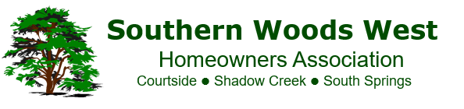

HOA Tree Incident Form

* The HOA is **only** responsible for trees in the common area.
* The HOA will **only** trim, cut down, or remove a tree from the common area if it poses a threat to persons or property. As a general rule, the HOA will leave fallen trees in the common area untouched.
* Common area tree branches that overhang into a homeowner’s property may be trimmed by the homeowner. The HOA is only responsible if there is a threat to persons or property.

**Homeowner Name:** Click or tap here to enter text.

**Homeowner Address:** Click or tap here to enter text.

**Location (if different from homeowner’s address):** Click or tap here to enter text.

**Issue:** Click or tap here to enter text.

*Note: To expedite the request, please include photos. The inclusion of at least one zoomed-out photo is requested to help provide a visual of the tree in relation to its surroundings.*

**Please send the completed form and photos to** **tree@swwhoa.com**